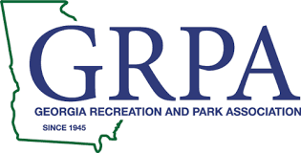
“Class A/B” State Baseball
Statesboro, GA
June 21-25, 2022

Mill Creek Regional Park Parking

Parking is available inside the confines of Mill Creek Regional Park. Visitors must park in one of our approved parking spots in any of our facility parking lots. No parking will be allowed in non-approved locations such as grass areas, curbs, along sidewalks or along the roadside adjacent to the park. Our back parking lot gate will be open for exit only during the duration of the tournament.

